Name: Lai Trung Minh Duc (DucLTM)  
Student ID: SE62220  
Class: IA1161  
Email: [DucLTMSE62220@fpt.edu.vn](mailto:DucLTMSE62220@fpt.edu.vn)  
Subject: PFC – PRF192

ASSIGNMENT REPORT

Option 1:

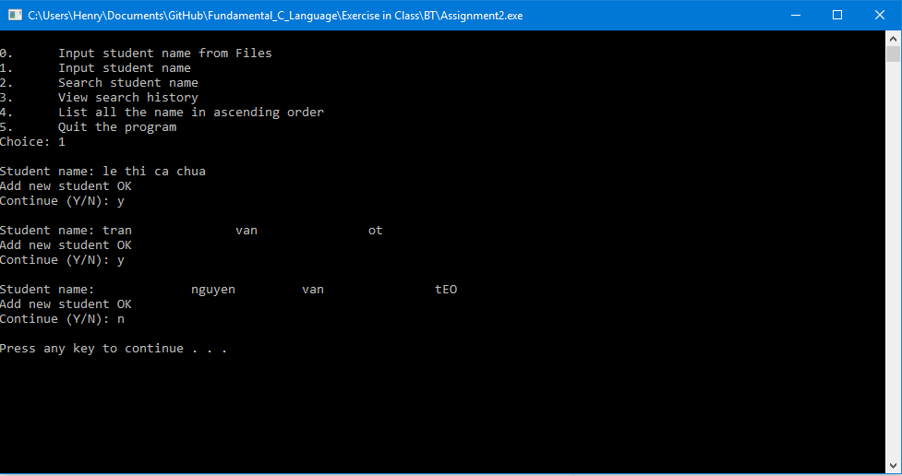

Option 2:

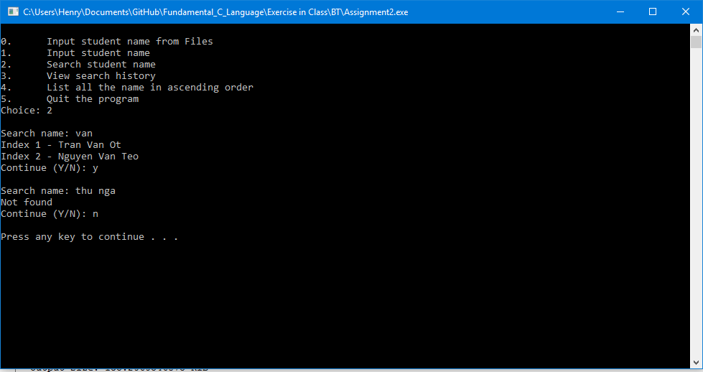

Option 3:

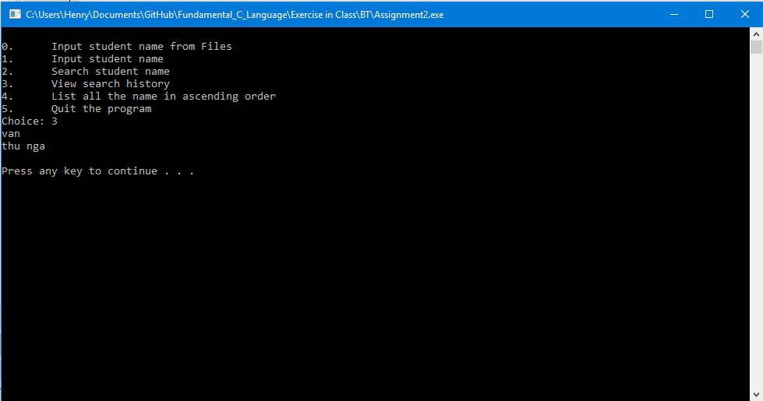

Option 4:

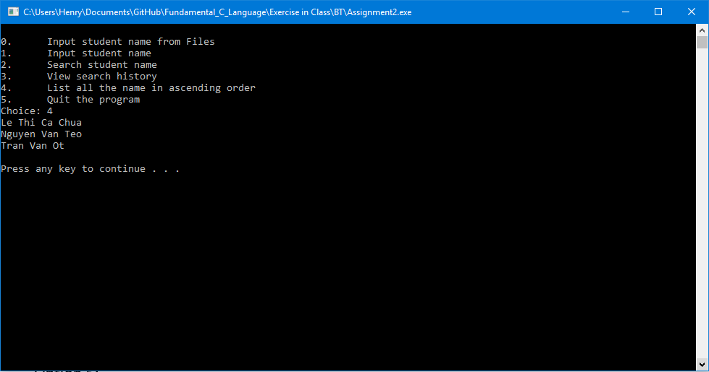

Option 5:

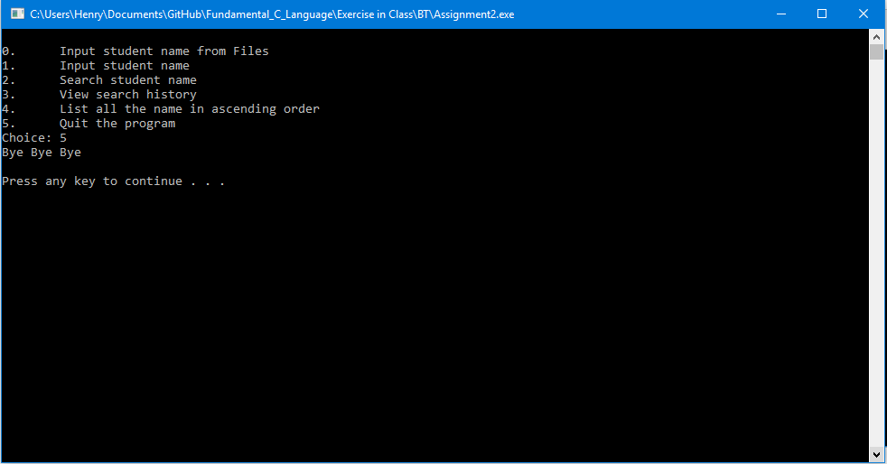

Bonus Option 0:

